Practical - 2
Practical Title: Semantic HTML5 Pages with Accessibility-Ready Structure

Problem Definition: Develop static HTML5 skeletons for at least 10 StudentHub pages such as Home, About, Register, Login, Dashboard, Events, Profile, Contact, Admin, FAQ, and Feedback. Use semantic tags and accessibility-friendly structure.

Theory

1. Are semantic tags such as header, nav, main, section, article, aside, and footer used properly?
Answer:
Yes. The website uses semantic HTML5 tags appropriately to organize the page structure and improve readability, accessibility, and SEO.

2. Are form labels, headings, image alt text, and navigation links accessible?
Answer:
Yes. All form fields have associated labels, headings follow a logical hierarchy, images include descriptive alt text, and navigation links are clear and keyboard accessible.

3. Is the page structure consistent across all pages?
Answer:
Yes. All pages follow a consistent layout with the same header, navigation menu, main content area, and footer, providing a uniform user experience.

Implementation

<html> – Root element that contains the entire HTML document.

<head> – Contains metadata, title, links to CSS, and other resources.

<title> – Defines the title of the web page displayed in the browser tab.

<body> – Contains all visible content of the web page.

<header> – Represents the introductory section or page header.

<nav> – Defines the navigation menu with links.

<main> – Contains the primary content of the page.

<footer> – Represents the footer section of the page.

<h1> to <h6> – Defines headings from highest to lowest level.

<p> – Defines a paragraph of text.

<a> – Creates hyperlinks to other pages or resources.

<img> – Displays an image with an alt attribute for accessibility.

<form> – Creates a form to collect user input.

<label> – Provides a label for form controls.

<input> – Accepts user input such as text, email, or password.

<button> – Creates a clickable button.

<ul> – Creates an unordered (bulleted) list.

• Evidence of Work (Screenshots)

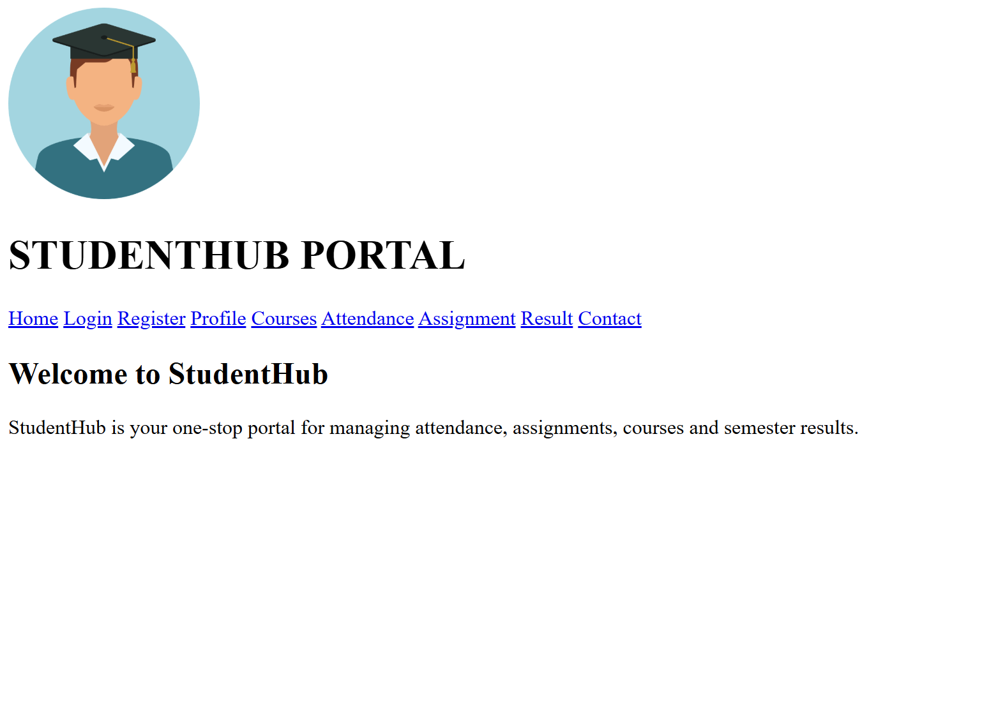
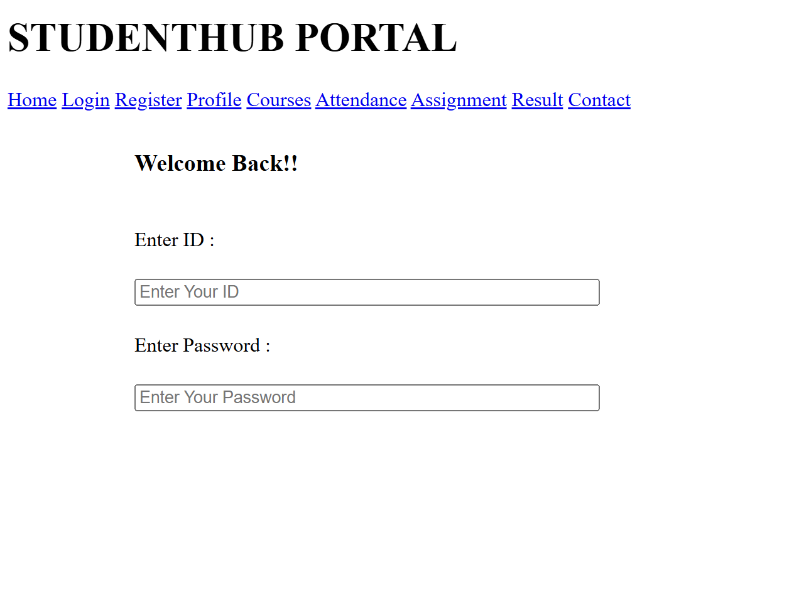
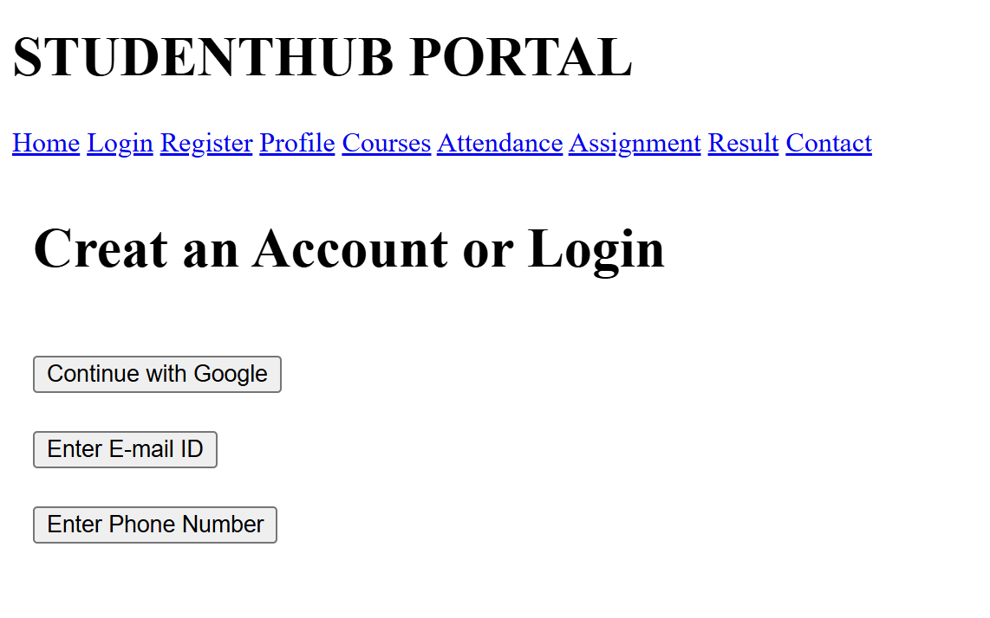
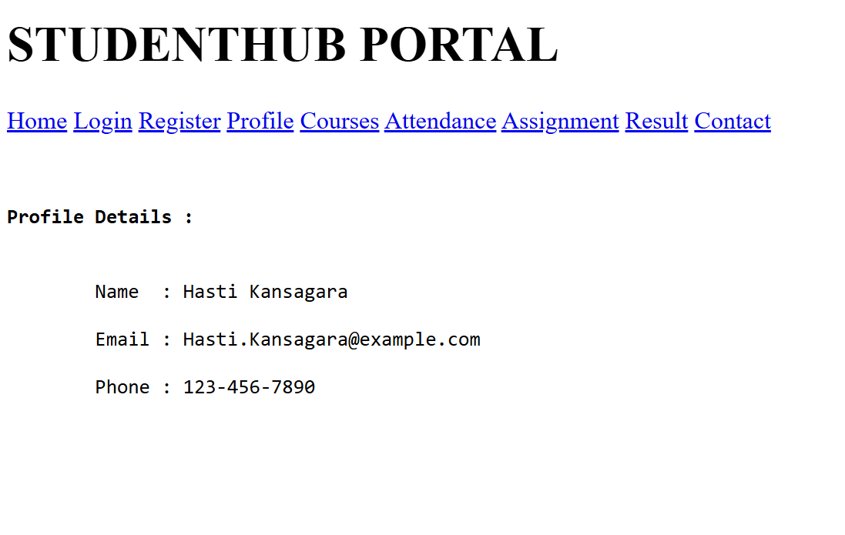
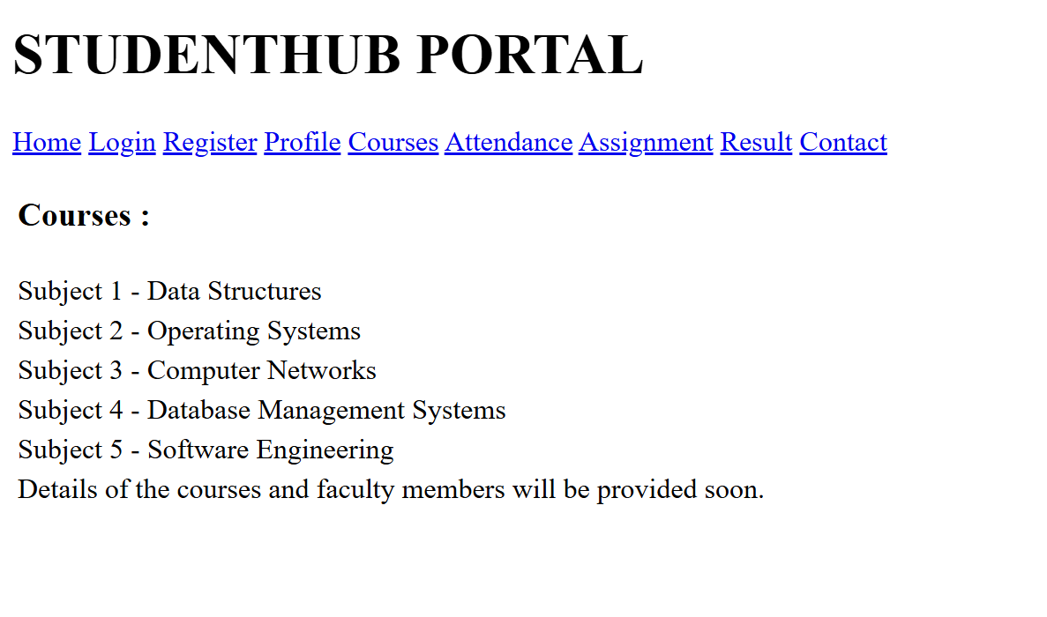
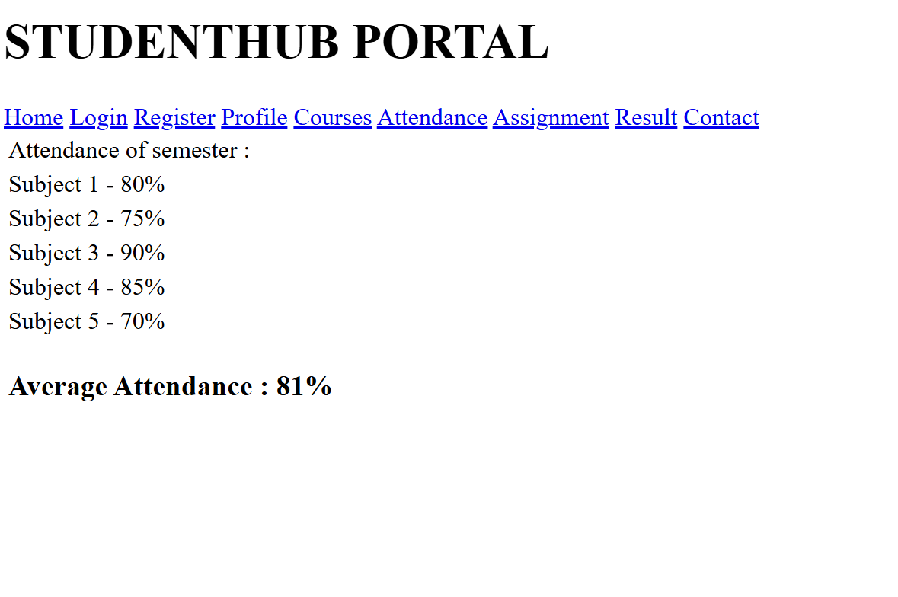
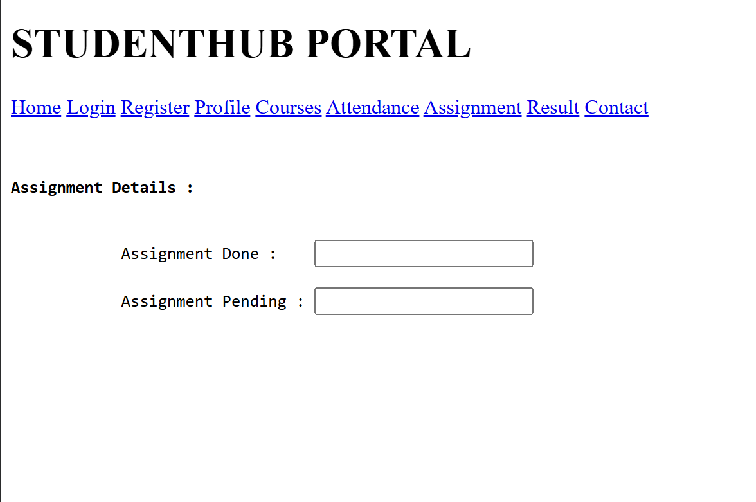
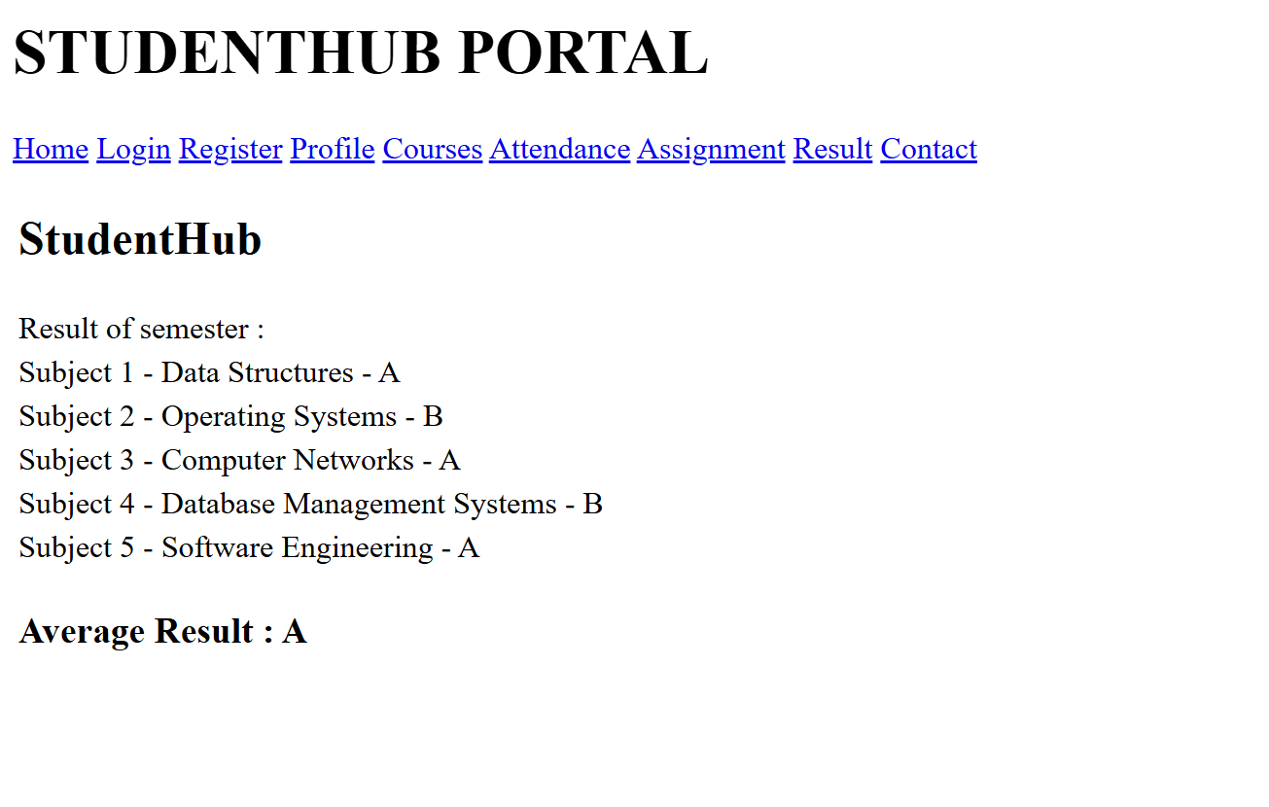
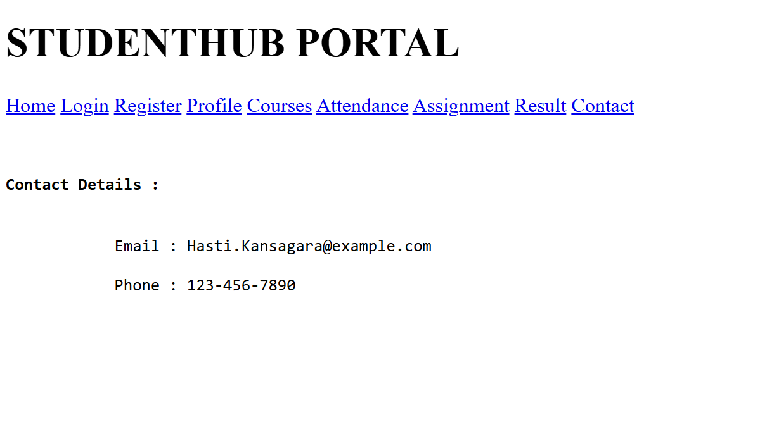

GitHub Repository Link:

https://github.com/kansagarahasti24/WDF/tree/main/Practical%202

Challenges Faced:

- Using HTML5 semantic tags correctly.
- Maintaining a consistent page structure.
- Creating accessible forms and navigation.
- Organizing content logically.
- Ensuring proper heading hierarchy.
- Avoiding HTML syntax errors.
- Keeping layouts uniform across pages.
- Following HTML5 and accessibility standards.

Learning Outcomes:
- Learned to create HTML5 page structures using semantic tags.
- Understood the importance of accessibility-friendly web design.
- Developed skills in organizing content with a proper layout.
- Learned to create consistent structures for multiple web pages.
- Built a strong foundation for future CSS styling and JavaScript development.

Faculty Remarks: (Keep this blank for faculty)

